**Assignment 4-Use of Joins and different functions**

**Functions used in this document:**

* All types of Joins.
* Subqueries
* EXISTS, ANY, All
* ASCII, LEGNTH, LOWER, REVERSE, REPLACE, UPPER
* NOW, DATE_ADD, TIMESTAMP, MONTH, DAY, YEAR
* ABS, SIN, CEIL, EXP, FLOOR, LOG
* AVG, COUNT, MIN, MAX, SUM, DISTINCT

**JOINS**

**Inner Join**

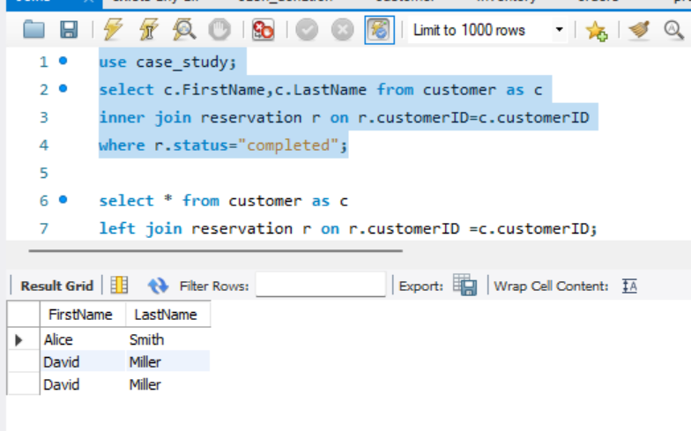

**Left Join**

**Right Join**

**Cross Join**

**Natural Join**

**Non-equi Join**

**Having, Group By**

**Order By**

**Aggregate function: sum with join and group by**

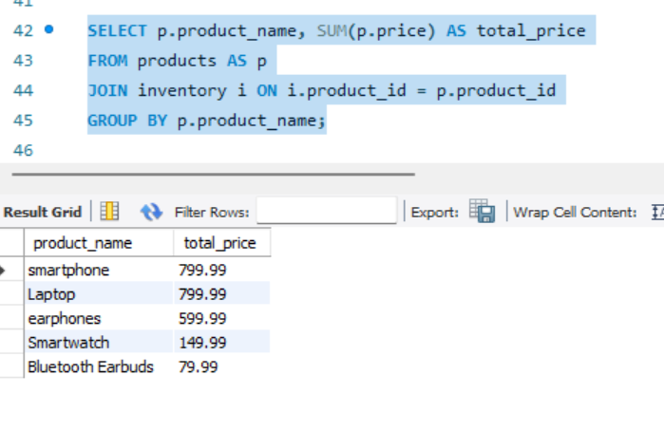

**SUBQUERY, EXISTS, ANY, ALL**

**Exists and Subquery**

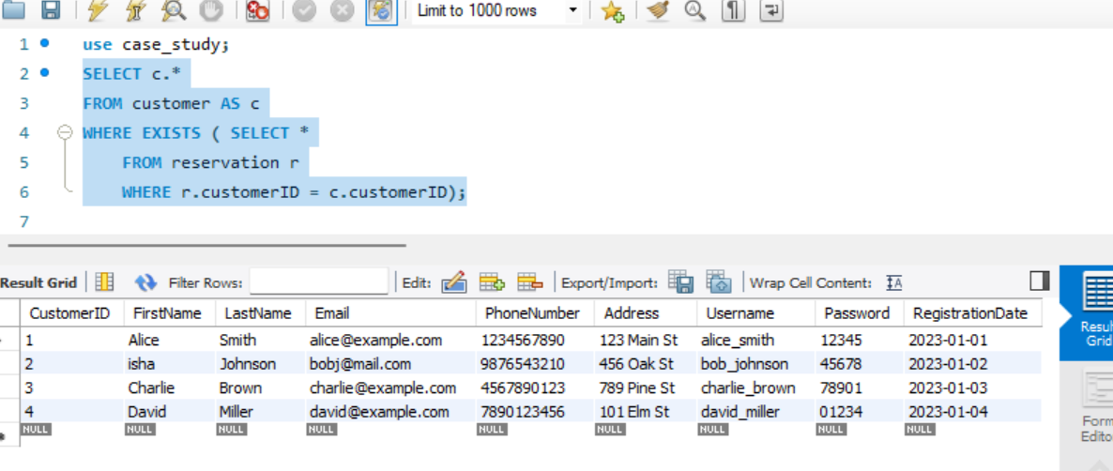

**All and Subquery**

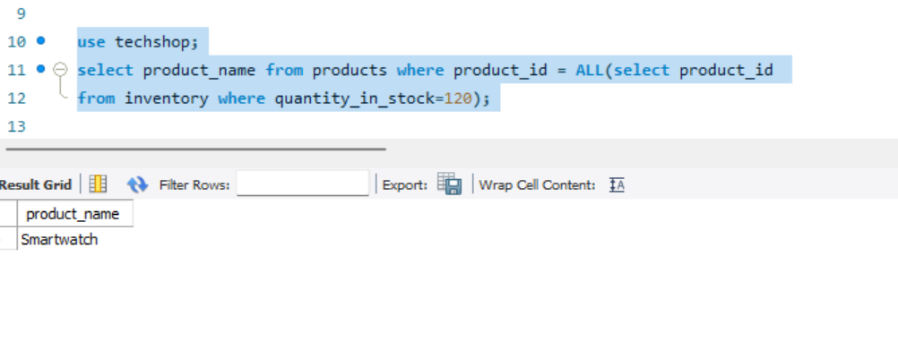

**Any and Subquery**

**STRING** **FUNCTIONS: ASCII, LEGNTH, LOWER, REVERSE, REPLACE, UPPER**

**Ascii**

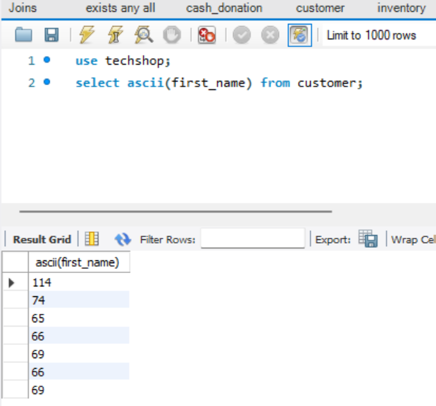

**Length**

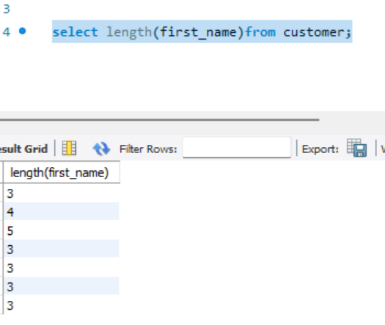

**LOWER**

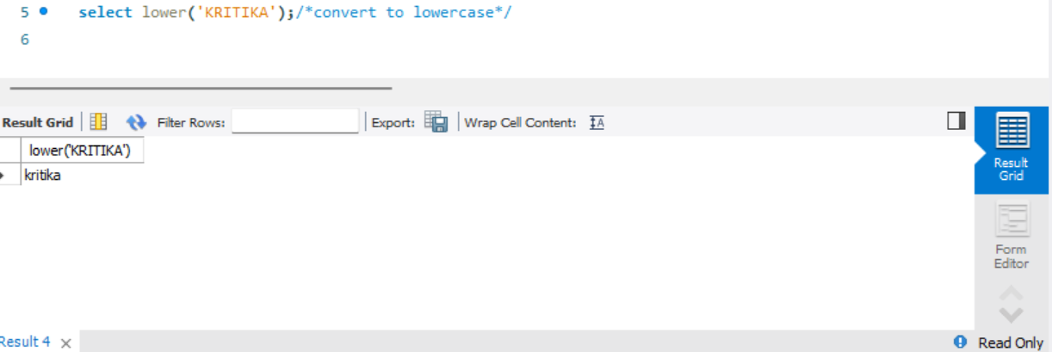

**REPLACE**

**Reverse**

**Upper**

**DATE FUNCTIONS: NOW, DATE_ADD, TIMESTAMP, MONTH, DAY, YEAR**

**Now**

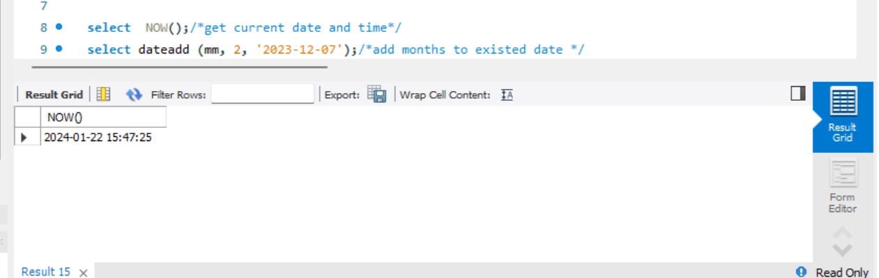

**Date_add()**

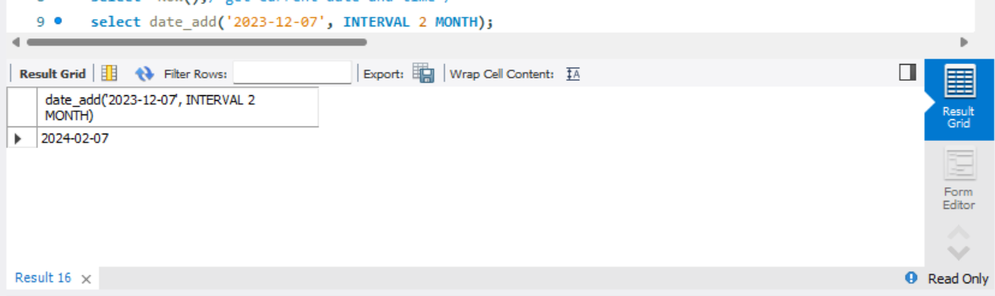

**Timestamp**

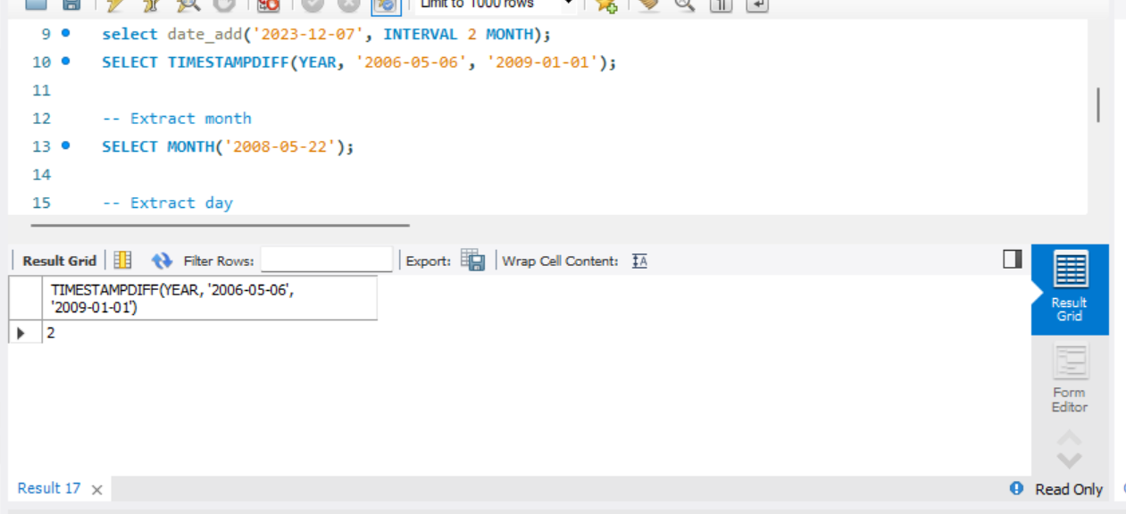

**Month**

**Day**

**Year**

**MATH FUNCTIONS: ABS, SIN, CEIL, EXP, FLOOR, LOG**

**Absolute**

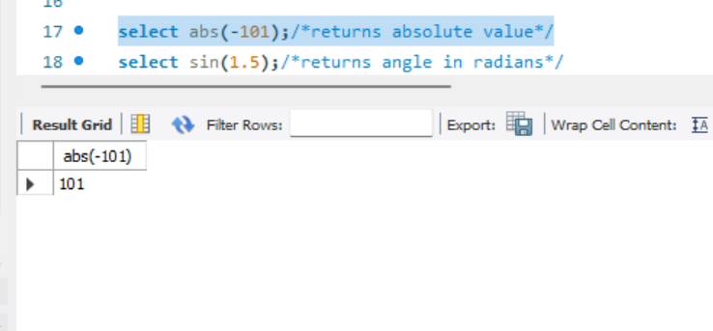

**For angle**

**Ceil**

**Floor**

**Exponential**

**Log**

**AGGREGATE FUNCIONS: COUNT, DISTINCT, MIN, MAX, SUM, AVG**

**Count**

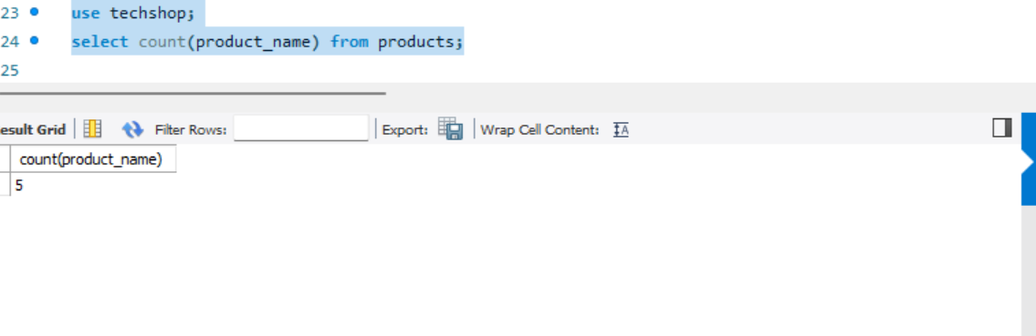

**Distinct**

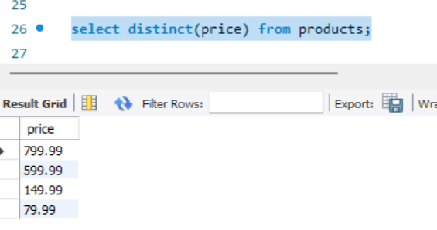

**Min**

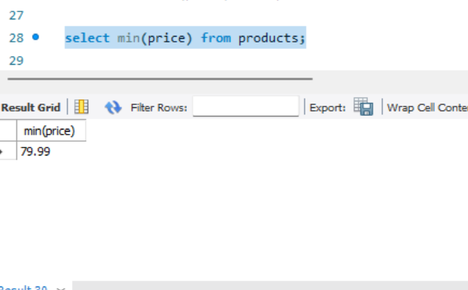

**Max**

**SUM**

**AVG**

